**Week – 2:**

**JUnit**

**Exercise 1: Setting Up JUnit**

**CALCULATOR TEST**

**Pom.xml:**

<project xmlns="http://maven.apache.org/POM/4.0.0"

xmlns:xsi="http://www.w3.org/2001/XMLSchema-instance"

xsi:schemaLocation="http://maven.apache.org/POM/4.0.0 https://maven.apache.org/xsd/maven-4.0.0.xsd">

<modelVersion>4.0.0</modelVersion>

<groupId>com.example</groupId>

<artifactId>JUnitExample</artifactId>

<version>0.0.1-SNAPSHOT</version>

<dependencies>

<dependency>

<groupId>junit</groupId>

<artifactId>junit</artifactId>

<version>4.13.2</version>

<scope>test</scope>

</dependency>

</dependencies>

</project>

CalculatorTest.java

import org.junit.Test;

import static org.junit.Assert.*;

public class CalculatorTest {

@Test

public void testAddition() {

int result = 2 + 3;

assertEquals(5, result);

    }

}

Output:

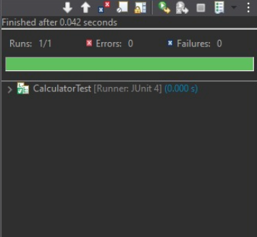

**Excerise-3: Assertions in JUnit**

**Pom.xml**

<project xmlns="http://maven.apache.org/POM/4.0.0"

xmlns:xsi="http://www.w3.org/2001/XMLSchema-instance"

xsi:schemaLocation="http://maven.apache.org/POM/4.0.0 https://maven.apache.org/xsd/maven-4.0.0.xsd">

<modelVersion>4.0.0</modelVersion>

<groupId>com.assertions</groupId>

<artifactId>AssertionDemo</artifactId>

<version>0.0.1-SNAPSHOT</version>

<dependencies>

<dependency>

<groupId>junit</groupId>

<artifactId>junit</artifactId>

<version>4.13.2</version>

<scope>test</scope>

</dependency>

</dependencies>

</project>

**AssertionsTest.java:**

import static org.junit.Assert.*;

import org.junit.Test;

public class AssertionsTest {

@Test

public void testAssertions() {

// Assert equals

assertEquals(5, 2 + 3);

// Assert true

assertTrue(5 > 3);

// Assert false

assertFalse(5 < 3);

// Assert null

assertNull(null);

// Assert not null

assertNotNull(new Object());

    }

**Output:**

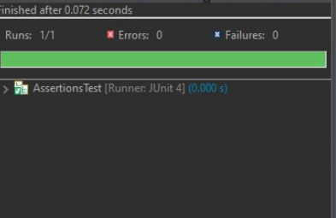

**Excerise-4: Arrange-Act-Assert (AAA) Pattern, Test Fixtures, Setup and Teardown Methods in JUnit**

**Pom.xml:**

<project xmlns="http://maven.apache.org/POM/4.0.0"

xmlns:xsi="http://www.w3.org/2001/XMLSchema-instance"

xsi:schemaLocation="http://maven.apache.org/POM/4.0.0 https://maven.apache.org/xsd/maven-4.0.0.xsd">

<modelVersion>4.0.0</modelVersion>

<groupId>com.aaa</groupId>

<artifactId>AAADemo</artifactId>

<version>1.0-SNAPSHOT</version>

<dependencies>

<dependency>

<groupId>junit</groupId>

<artifactId>junit</artifactId>

<version>4.13.2</version>

<scope>test</scope>

</dependency>

</dependencies>

</project>

(src/main/java we should create com.aa)

* Calculator.java
* package com.aaa;

**Calculator.java**

public class Calculator {

public int add(int a, int b) {

return a + b;

}

public int subtract(int a, int b) {

return a - b;

    }

}

* package-info.java - package com.aaa;

**src/test/java**

-com.aaa

->CalculatorTest.java ->package com.aaa;

**CalculatorTest.java**

import org.junit.After;

import org.junit.Before;

import org.junit.Test;

import static org.junit.Assert.*;

public class CalculatorTest {

private Calculator calculator;

@Before

public void setUp() {

System.out.println("Setting up...");

calculator = new Calculator();

}

@After

public void tearDown() {

System.out.println("Tearing down...");

calculator = null;

}

@Test

public void testAddition() {

// Arrange

int a = 10, b = 20;

// Act

int result = calculator.add(a, b);

// Assert

assertEquals(30, result);

}

@Test

public void testSubtraction() {

// Arrange

int a = 50, b = 20;

// Act

int result = calculator.subtract(a, b);

// Assert

assertEquals(30, result);

    }

}

package-info.java - package com.aaa;

**Output:**

